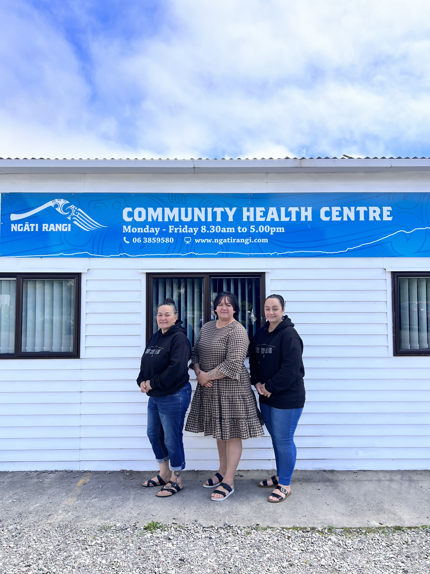  Our Team  From left:  Tina Wallace - Tamariki Ora Nurse  Wendy-Lee Tapa - Pou Whirinaki (Manager)  Katherine Herewini – Kaiawhina | Nga Waihua o Paerangi Trust  Ngati Rangi Community Health Centre  36A Burns Street  OHAKUNE  Contact Us  Phone: 06 3859580  Email: katherine.herewini@ngatirangi.com | Nga Waihua O Paerangi Trust
Our Service  Our Tamariki Ora Service is provided by our Tamariki Ora Nurse and Kaiawhina, who primarily provide Well Child Checks, assessments of Tamariki and well-being, and information relating to health issues and health care services to whanau from birth to 5 years.  Our service is aimed at keeping tamariki well, growing to their fullest potential and to contribute to the reduction in health inequalities.  All information collected about whanau and Tamariki during the course of this service will be kept confidential to the extent permitted by law. Whanau will be identified in our service records. Information that identifies whanau will not be released outside of the service without the whanau permission. | Well Child Tamariki Ora Programme  The Well Child Tamariki Ora Program is a package of free health services available for all New Zealand children from birth to before they start school.  This includes:  Health and development assessments Behavior vision, hearing, oral health and immunisations.  Family/Whanau care and Support  Help with breastfeeding, safe sleep advise, smokefree support and connecting your whanau with community services.  Health education  Helping you understand the different stages of your child’s development.  For more information about our service please feel free to contact one of our friendly team  Tina 0272928159  Katherine 0274758347 | B4 School Checks  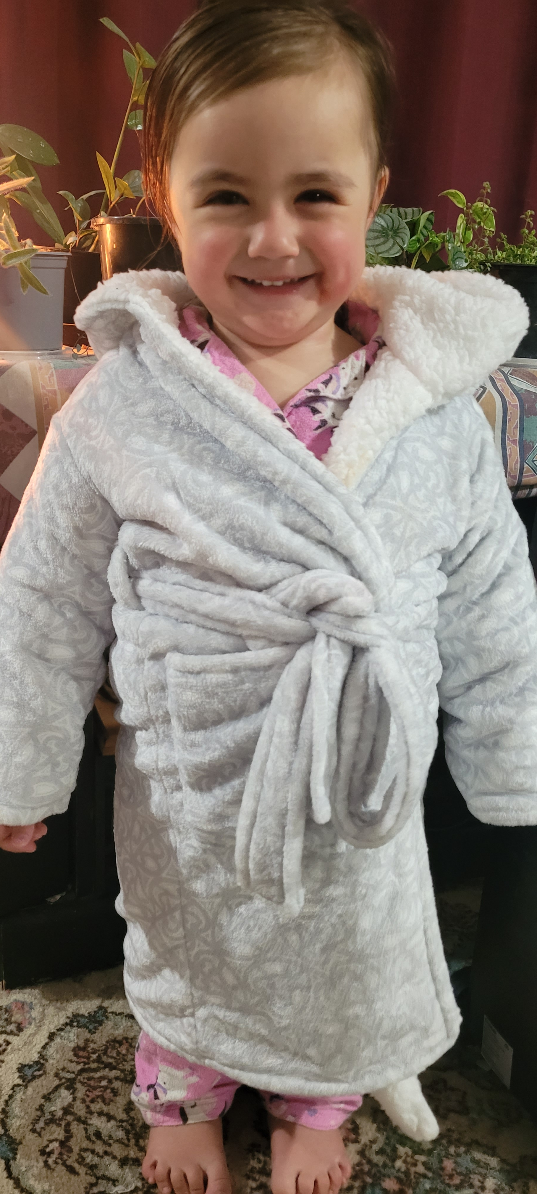  The B4 School Check is a free health and development check for your four-year-old. This is completed by your GP (family doctor) and a Registered Nurse. It’s the last Well Child Tamariki Ora check and helps give your child the best start at school. Remember to take your child's My Health Book with you to their appointment.

