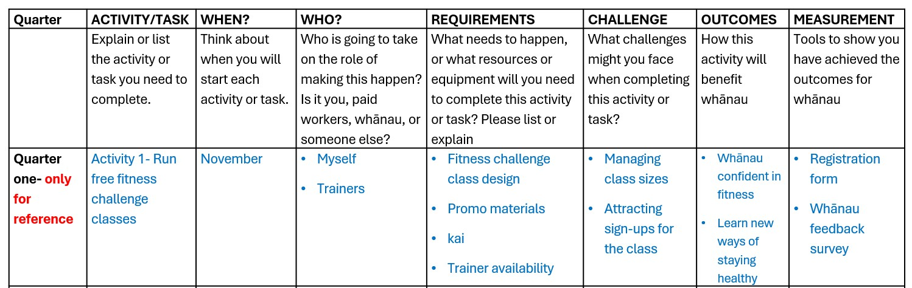

The **Implementation Plan Template** helps you:

* **Set clear goals:** Everyone knows what needs to be done and why.
* **Use resources wisely:** Manage your team, budget, and time effectively.
* **Stay on schedule:** Keep your project on track with deadlines and milestones.
* **Reduce risks:** Plan for possible challenges.
* **Provide a reference:** Everyone involved can use it as a common guide.

How it works

* The plan is split into **reporting quarters**.
* Aim for **at least two activities or tasks per quarter**.

Example only for reference

* If you are starting a fitness kaupapa to improve the health of your whānau.

|  |  |  |  |  |  |  |  |
| --- | --- | --- | --- | --- | --- | --- | --- |
| **Quarter** | **ACTIVITY/TASK** | **WHEN?** | **WHO?** | **REQUIREMENTS** | **CHALLENGE** | **OUTCOMES** | **MEASUREMENT** |
|  | Explain or list the activity or task you need to complete. | Think about when you will start each activity or task. | Who is going to take on the role of making this happen?  Is it you, paid  workers, whānau, or  someone else? | What needs to happen, or what resources or equipment will you need to complete this activity or task? Please list or  explain | What challenges might you face when completing this activity or task? | How this activity will benefit whānau | Tools to show you have achieved the outcomes for whānau |
| **Quarter**  **one** |  |  |  |  |  |  |  |
|  |  |  |  |  |  |  |  |
| **Quarter two** |  |  |  |  |  |  |  |
|  |  |  |  |  |  |  |  |
| **Quarter**  **three** |  |  |  |  |  |  |  |
|  |  |  |  |  |  |  |  |
| **Quarter four** |  |  |  |  |  |  |  |
|  |  |  |  |  |  |  |  |